Prerequisites
- Download jdk and set the path variable in the environment variables
To verify installation
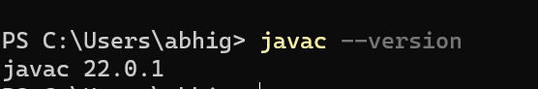
- Install Tomcat
- Install MySQL from mysql community downloads and follow the instructions to configure the server.
- After successfully installing MySQL Shell, Workbench, and Server, run \connect root@localhost in MySQL shell and enter the password set up during the configuration to establish the connection.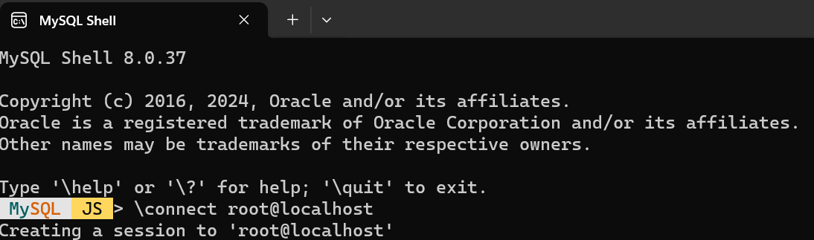
- Download the mysql-java connector zip file and extract jar file.
- Add this jar file to the lib folder of Tomcat
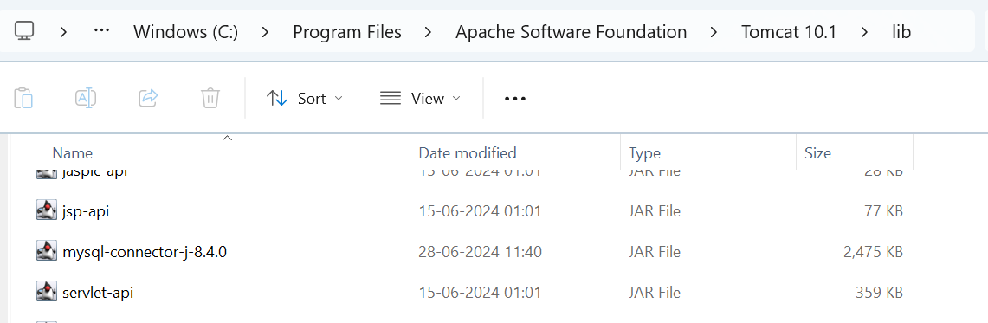
Directory structure for servlets
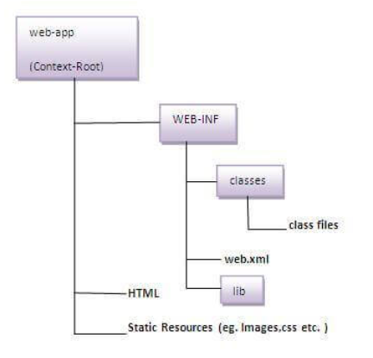
Creating table in MySQL Workbench
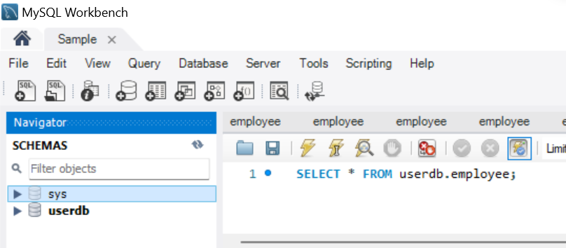
- Select the pointed icon to create a new schema
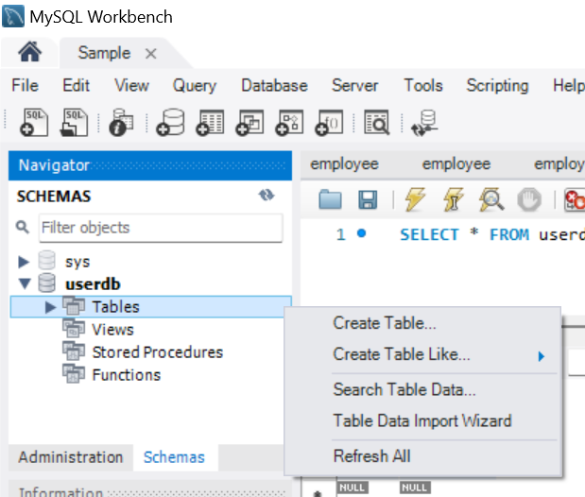
2.Click on the created schema to view the options. Right click on tables to create a new table. Enter the table name, column name, corresponding datatypes and click on apply changes to create a table.
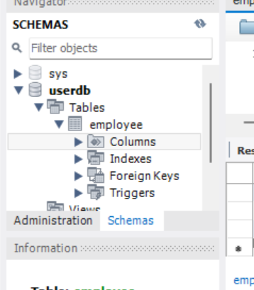
3.Once the table is created successfully, we can find the details about columns as shown

4. Add the data into table and click on apply to insert rows.
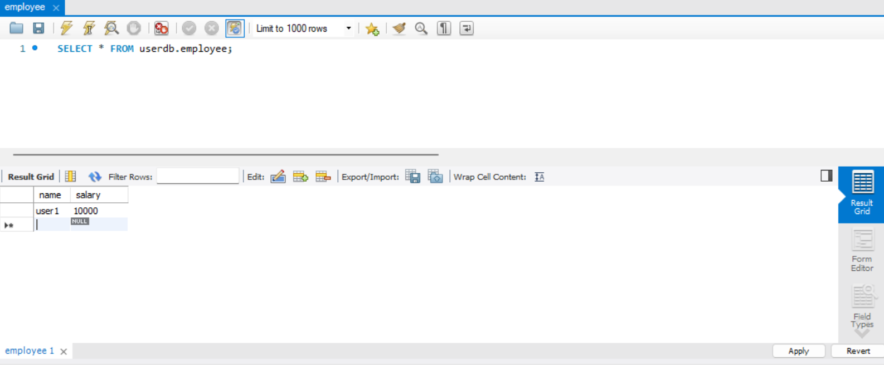

CRUD Operations using servlet
1. Create a folder named "users" in “webapps” folder(Tomcat).
- Within the "users" folder, create another folder named "WEB-INF".
- Inside the "WEB-INF" folder, create a folder named "classes".
- Create an HTML file named "index.html" in the "users" folder.
- Create an XML file named "web.xml" in the "WEB-INF" folder.
- Create a Java file named "Employee.java" in the "classes" folder.
index.html
<!DOCTYPE html>
<html>
<head>
<title>Employee Management</title>
</head>
<body>
<center>
<h3>Employee Management Page</h3>
<!-- Create Employee Form -->
<form name="create" method="post" action="http://localhost:8080/users/Employee">
<h4>Create Employee</h4>
<table>
<tr>
<td>Username:</td>
<td><input type="text" name="username"></td>
</tr>
<tr>
<td>Salary:</td>
<td><input type="text" name="salary"></td>
</tr>
</table>
<input type="submit" value="Create">
</form>
<br/>
<!-- Read Employee Form -->
<form name="read" method="get" action="http://localhost:8080/users/Employee">
<h4>Read Employee</h4>
<table>
<tr>
<td>Username:</td>
<td><input type="text" name="username"></td>
</tr>
</table>
<input type="submit" value="Read">
</form>
<br/>
<!-- Update Employee Form -->
<form name="update" method="post" action="http://localhost:8080/users/Employee" onsubmit="return confirm('Are you sure you want to update?')">
<input type="hidden" name="_method" value="put">
<h4>Update Employee</h4>
<table>
<tr>
<td>Username:</td>
<td><input type="text" name="username"></td>
</tr>
<tr>
<td>Salary:</td>
<td><input type="text" name="salary"></td>
</tr>
</table>
<input type="submit" value="Update">
</form>
<br/>
<!-- Delete Employee Form -->
<form name="delete" method="post" action="http://localhost:8080/users/Employee" onsubmit="return confirm('Are you sure you want to delete?')">
<input type="hidden" name="_method" value="delete">
<h4>Delete Employee</h4>
<table>
<tr>
<td>Username:</td>
<td><input type="text" name="username"></td>
</tr>
</table>
<input type="submit" value="Delete">
</form>
</center>
</body>
</html>
web.xml
<web-app>
<servlet>
<servlet-name>Employee</servlet-name>
<servlet-class>Employee</servlet-class>
</servlet>
<servlet-mapping>
<servlet-name>Employee</servlet-name>
<url-pattern>/Employee/*</url-pattern>
</servlet-mapping>
<servlet-mapping>
<servlet-name>Employee</servlet-name>
<url-pattern>/Employee</url-pattern>
</servlet-mapping>
</web-app>

Employee.java
import java.io.*;
import jakarta.servlet.*;
import jakarta.servlet.http.*;
import java.sql.*;

public class Employee extends HttpServlet {

@Override
protected void doGet(HttpServletRequest req, HttpServletResponse res) throws IOException, ServletException {
res.setContentType("text/html");
PrintWriter out = res.getWriter();
String username = req.getParameter("username");

try {
Class.forName("com.mysql.cj.jdbc.Driver");
Connection con = DriverManager.getConnection("jdbc:mysql://localhost:3306/userdb", "root", "root");

String query = "SELECT salary FROM employee WHERE name = ?";
PreparedStatement pst = con.prepareStatement(query);
pst.setString(1, username);

ResultSet rs = pst.executeQuery();
if (rs.next()) {
out.println("Salary: " + rs.getObject(1));
} else {
out.println("Employee not found");
}
con.close();
} catch (Exception e) {
e.printStackTrace(out);
}
}

@Override
protected void doPost(HttpServletRequest req, HttpServletResponse res) throws IOException, ServletException {
res.setContentType("text/html");
PrintWriter out = res.getWriter();
String method = req.getParameter("_method");

// Check _method parameter for PUT or DELETE
if ("put".equalsIgnoreCase(method)) {
doPut(req, res);
return;
} else if ("delete".equalsIgnoreCase(method)) {
doDelete(req, res);
return;
}

// Handle POST request (create operation)
String username = req.getParameter("username");
String salary = req.getParameter("salary");

try {
Class.forName("com.mysql.cj.jdbc.Driver");
Connection con = DriverManager.getConnection("jdbc:mysql://localhost:3306/userdb", "root", "root");

// Check if the employee already exists
String checkQuery = "SELECT * FROM employee WHERE name = ?";
PreparedStatement checkPst = con.prepareStatement(checkQuery);
checkPst.setString(1, username);
ResultSet checkRs = checkPst.executeQuery();

if (checkRs.next()) {
out.println("Employee already exists");
} else {
// Insert new employee
String insertQuery = "INSERT INTO employee (name, salary) VALUES (?, ?)";
PreparedStatement pst = con.prepareStatement(insertQuery);
pst.setString(1, username);
pst.setString(2, salary);

int rows = pst.executeUpdate();
if (rows > 0) {
out.println("Employee created successfully");
} else {
out.println("Error creating employee");
}
}
con.close();
} catch (Exception e) {
e.printStackTrace(out);
}
}

@Override
protected void doPut(HttpServletRequest req, HttpServletResponse res) throws IOException, ServletException {
res.setContentType("text/html");
PrintWriter out = res.getWriter();
String username = req.getParameter("username");
String salary = req.getParameter("salary");

try {
Class.forName("com.mysql.cj.jdbc.Driver");
Connection con = DriverManager.getConnection("jdbc:mysql://localhost:3306/userdb", "root", "root");

String updateQuery = "UPDATE employee SET salary = ? WHERE name = ?";
PreparedStatement pst = con.prepareStatement(updateQuery);
pst.setString(1, salary);
pst.setString(2, username);

int rows = pst.executeUpdate();
if (rows > 0) {
out.println("Employee updated successfully");
} else {
out.println("Error updating employee or employee does not exist");
}
con.close();
} catch (Exception e) {
e.printStackTrace(out);
}
}

@Override
protected void doDelete(HttpServletRequest req, HttpServletResponse res) throws IOException, ServletException {
res.setContentType("text/html");
PrintWriter out = res.getWriter();
String username = req.getParameter("username");

try {
Class.forName("com.mysql.cj.jdbc.Driver");
Connection con = DriverManager.getConnection("jdbc:mysql://localhost:3306/userdb", "root", "root");

String deleteQuery = "DELETE FROM employee WHERE name = ?";
PreparedStatement pst = con.prepareStatement(deleteQuery);
pst.setString(1, username);

int rows = pst.executeUpdate();
if (rows > 0) {
out.println("Employee deleted successfully");
} else {
out.println("Error deleting employee or employee does not exist");
}
con.close();
} catch (Exception e) {
e.printStackTrace(out);
}
}
}

Execution
- To execute the servlet code, first compile the Java code. Open the command prompt in the folder containing the Java file. Then run the command javac -cp "(path to servlet-api.jar in Tomcat's lib)" file-name.
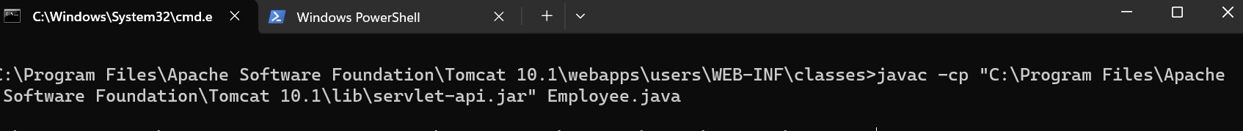
- Start the Tomcat server by clicking on startup in the Tomcat/bin directory.
- Enter the path to the HTML file in any browser, using host localhost:8080.
This is the html page.
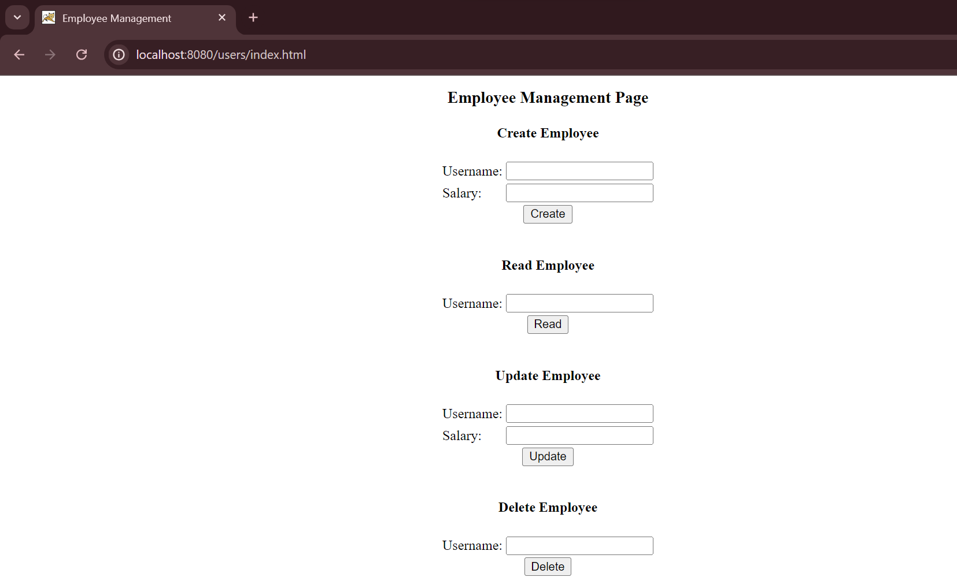

Database
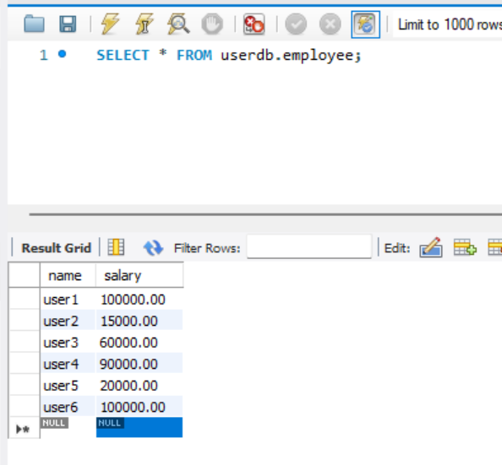
Output Take a look at the output!

